­­­­­­­­­­­­­

**Regular Schedule:**

|  |  |  |
| --- | --- | --- |
| **Sunday:** | Bible Classes | 10:00 am |
|  | Assembly | 11:00 am |
|  | Assembly | 6:00 pm |
| **Wednesday:** | Bible Classes | 7:00 pm |

**Duty Roster**(02/05/17 –02/08/17):

|  |  |  |  |
| --- | --- | --- | --- |
| **Duties** | **Sunday A.M.** | **Sunday P.M.** | **Weds. P.M.** |
| Announcements | O”banion,P |  |  |
| Lead Singing | Andrews,C | Gurtler,J | O’banion,P |
| Read Bible | Mounts,J |  |  |
| Preside Table | McLellan,A | Lewis,M |  |
| Serve Table | Shreve,S |  |  |
| Serve Table | Shreve,N |  |  |
| Serve Table | Dowell,P |  |  |
| Opening Prayer | Driedger,T | Manganello,J | McLellan,A |
| Closing Prayer | Wolfgang,J | Wisdom,M |  |
| Preach or Weds. Invitation |  |  | Andrews,C |

|  |  |  |  |  |  |
| --- | --- | --- | --- | --- | --- |
|  | | | | | |
| **Prayer Requests**   * Remember the new, on-going, and general prayer requests on Joe’s  prayer list. * Remember those mentioned during Wednesday and Sunday assemblies**.**   **WHAT MUST I DO TO BE SAVED?** | | | | |
| 1. Hear the Gospel | (Acts 15:7) | 1. Believe in Jesus | (Acts 8:12) |
| 1. Repent of My Sins | (Acts 3:19) | 1. Confess Jesus | (Acts 8:37) |
| 1. Be Baptized in Water | (Acts 22:16) | 1. Remain Faithful | (Acts 2:42) |

­­­­­ Sunday February 5, 2017

**The Exton Exhorter**

WELCOME TO OUR VISITORS!

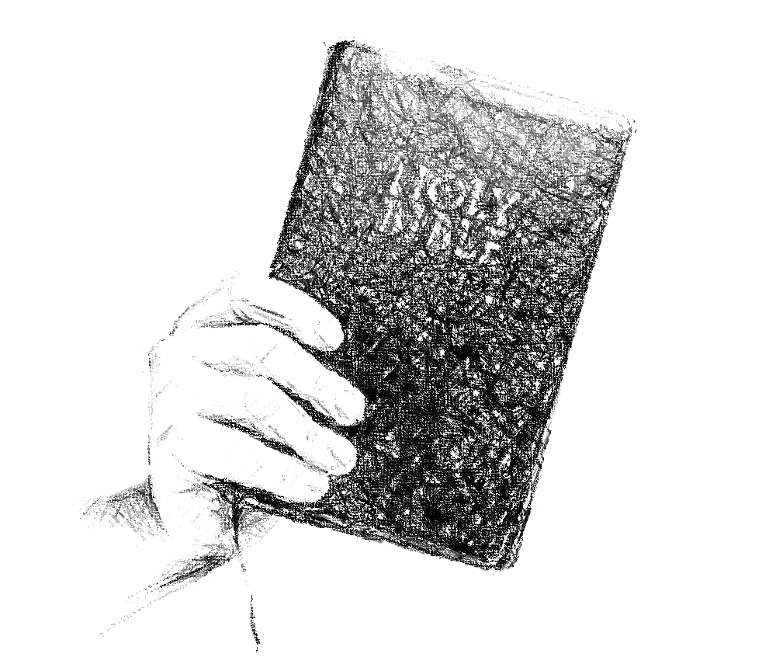

***Exton***

**CHURCH OF CHRIST**

217 North Whitford Road

Exton, PA 19341

**Phone**: 1-610-363- 8042

**Email**: [extonpachurch@gmail.com](mailto:extonpachurch@gmail.com)

**Website**: [www.extonchurch.org](http://www.extonchurch.org)

“Righteousness and justice are the foundation of your throne; steadfast love and faithfulness go before you.” Psalm 89:15 (ESV)

**Volume 2, Issue 30**

When we speak of the church of Christ, we not are speaking of all the amorphous disparate groups called “Christendom.” It is our goal to be just what Jesus established. The churches in the New Testament did not split into groups of denominations. Each congregation was directly answerable only to our King in heaven, and to no one else on earth. Christians met in their localities as spiritual communities of saints sharing the work and worship assigned them by God’s word. A mutual understanding of that, and dedication to that is all that bound them together.

And when we speak of the church of Christ we do not speak of all those subsequent denominations. We seek identity with the people in the New Testament who were Christ’s church, his assembly, and all other people in the world so doing. In the New Testament, local groups of such were called churches of Christ (Rom. 16:16). One would be a church of Christ as we purport to be here. At  some specific geographical place such could be called the church of God at Corinth (I Cor. 1:2), or the church (assembly) of the Thessalonians in God (I Thess. 1:1). That is all we aspire to be. That is what Christ orders we be, the saints at wherever our locality (Phil. 1:1), holding the pattern of sound words (II Tim. 1:13), not forms, teachings, and practices ordered by a clergy or other governing body.

Dale Smelser

The Church of Christ

When you visit and hear us refer to ourselves as a church of Christ, let us explain that.

Jesus called the church His: “I will build my church” (Mt. 16:18). The word translated church means “assembly.” It describes an assembly of any kind. There are all kinds of assemblies in this world for all kinds of purposes. But out of all of them, religious and secular, there is one group that belongs to Jesus. For the moment let us dismiss any concept of present religious groups and just think of what Christ established and referred to as his “church, assembly, or group.”

That assembly of people was bought with his blood (Acts. 20:28). He is the savior of that people (Eph. 5:23). What that means is that the church is simply the collection of the saved people of earth. When one is saved from his sins, the Lord adds him to that collection of people (Acts 2:47). If the church is the collection of the saved, obviously one cannot be among the saved if he is not in that church, or assembly. The church of Christ is simply all the saved collected in Christ and abiding there by faithful practice. Those are his church.

In the New Testament we find how those composing that assembly, or church, lived and served, and how collectively as local assemblies they worshiped and functioned. Christ being the head of the church (Eph. 1:22-23), human councils or hierarchies cannot determine those things. Human bodies cannot determine or change doctrine (II Jn. 9). All those things are already settled in the word of Christ (Jn. 16:12-15). As time has gone on, that order of things has become muddled by addition, neglect, and definite change in doctrine. Though Jesus established his church and told people in his word how to be saved, subsequent groups have changed those requirements and established their own membership requirements. Obviously groups with different membership requirements are not the same group of people. Not only do subsequent groups differ on how to be saved, they also differ from what Christ established as to work, mission, and function.