­­­­­­­­­­­­­

**Regular Schedule:**

|  |  |  |
| --- | --- | --- |
| **Sunday:** | Bible Classes | 10:00 am |
|  | Assembly | 11:00 am |
|  | Assembly | 6:00 pm |
| **Wednesday:** | Bible Classes | 7:00 pm |

**Duty Roster**(12/25/16 – 12/28/16):

|  |  |  |  |
| --- | --- | --- | --- |
| **Duties** | **Sunday A.M.** | **Sunday P.M.** | **Weds. P.M.** |
| Announcements | Lewis,M |  |  |
| Lead Singing | O’banion,P | Richardson,B | Lewis,M |
| Read Bible | Shreve,S |  |  |
| Preside Table | Dowell,P | Wisdom,M |  |
| Serve Table | Lee,L |  |  |
| Serve Table | Shreve,N |  |  |
| Serve Table | Andrews,J |  |  |
| Opening Prayer | McGibboney,G | Driedger,T |  |
| Closing Prayer |  | Robey,V | McGibboney,G |
| Preach or Weds. Invitation |  |  | Driedger,A |

|  |  |  |  |  |  |  |
| --- | --- | --- | --- | --- | --- | --- |
| |  | | --- | | **Bible Classes** |  * The Wednesday 7pm adult bible class is studying Kings of the Old Testament. * The Sunday 10am adult bible class is in the New Testament for the  “Read Through the Bible in A Year” series. | | | | | |
| **Prayer Requests**   * Remember the new, on-going, and general prayer requests on Joe’s  prayer list. * Remember those mentioned during Wednesday and Sunday assemblies**.**   **WHAT MUST I DO TO BE SAVED?** | | | | |
| 1. Hear the Gospel | (Acts 15:7) | 1. Believe in Jesus | (Acts 8:12) |
| 1. Repent of My Sins | (Acts 3:19) | 1. Confess Jesus | (Acts 8:37) |
| 1. Be Baptized in Water | (Acts 22:16) | 1. Remain Faithful | (Acts 2:42) |

­­­­­ Sunday December 25, 2016

**The Exton Exhorter**

WELCOME TO OUR VISITORS!

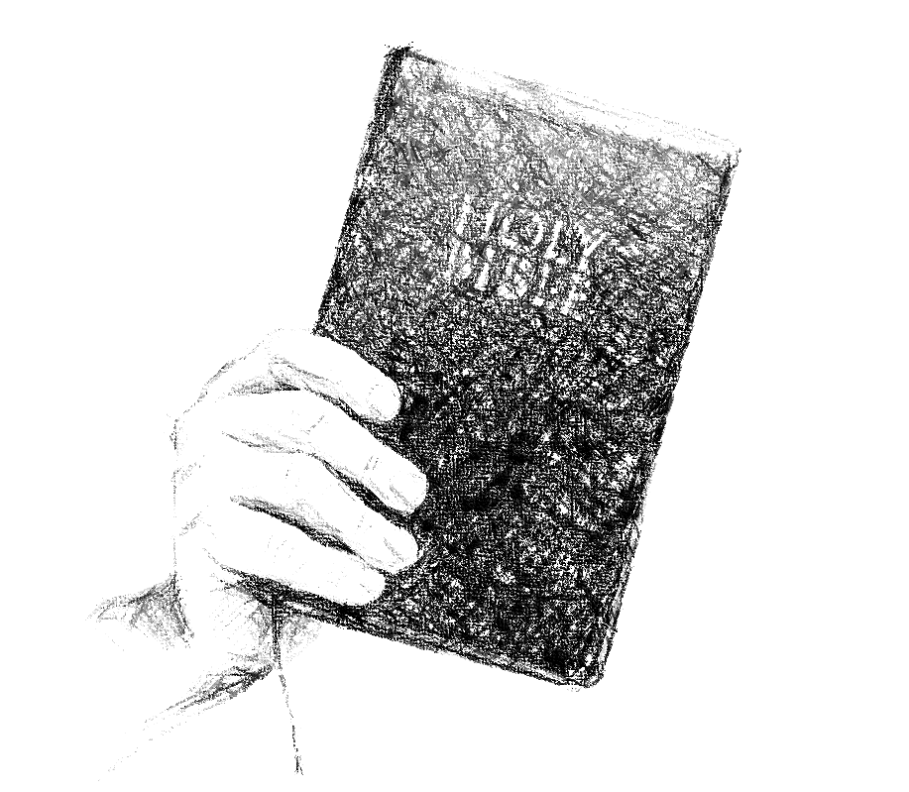

***Exton***

**CHURCH OF CHRIST**

217 North Whitford Road

Exton, PA 19341

**Phone**: 1-610-363- 8042

**Email**: [extonpachurch@gmail.com](mailto:extonpachurch@gmail.com)

**Website**: [www.extonchurch.org](http://www.extonchurch.org)

It is not good to eat much honey,  
     nor is it glorious to seek one's own glory.

Proverbs 25:27  **Volume 2, Issue 27**

Reasons For Your Faith

So often today, when one becomes disillusioned with human authority in religion or looks to escape the emptiness of near-sighted, irreligious materialism and embraces with deep fervor what he percieves to be real Christianity, he is caught up in an experiential religion that looks inward to one's own feelings. Often such people are characterized by conservative mores, a belief in the divine inspiration of the scriptures, and a willingness to confess their faith before others. But their "faith" is really a subjectively derived conviction which defies rational evaluation, a faith without objective reason.

Certainly New Testament Christianity is a walk "by faith, not by sight" (2 Cor. 5:7). However, that is not the same as saying a walk without reason. A blind man's decision as to when to cross the street is made with no less reason than a seeing man's decision. The blind man has faith in something outside himself (e.g., a seeing-eye dog), but that faith is based on reason (the training of the seeing-eye dog & the dog's past performance). This is simply to illustrate that walking by faith is not necessarily walking without reason. And indeed, the faith required by God is necessarily with reason. Rather than requiring faith apart from evidence, Jesus said, "If I do not the works (miracles) of my Father, believe me not. But if I do them, though ye believe not me, believe the works: that ye may know and understand that the Father is in me, and I in the Father." (John 10:37-38). The very purpose of the writing of the book of John was to provide reason "that ye may believe that Jesus is the Christ, the Son of God." Significantly this purpose is stated immediately following the account of Thomas' refusal to believe Jesus was raised without seeing the evidence (John 20:24-29). Verse 29 is not a contrast between reasonable and unreasonable faith, exalting the latter over the former. It is rather a contrast of the form of the evidence which provides faith.

    If reason compels you to cast aside an authoritarian religion which is based on superstition, or if reason compels you to look beyond the here and now, do not in turn forsake that reason which has brought you so far. Allow it to lead you to the truth.

By Jeff Smelser