­­­­­­­­­­­­­

**Regular Schedule:**

|  |  |  |
| --- | --- | --- |
| **Sunday:** | Bible Classes | 10:00 am |
|  | Assembly | 11:00 am |
|  | Assembly | 6:00 pm |
| **Wednesday:** | Bible Classes | 7:00 pm |

**Duty Roster**(10/ 27/16 – 10/30/16):

|  |  |  |  |  |  |  |
| --- | --- | --- | --- | --- | --- | --- |
| **Duties** | | **Sunday A.M.** | | **Sunday P.M.** | **Weds. P.M.** | |
| Announcements | | Mclellan,A | |  |  | |
| Lead Singing | | Mounts,J | | Manganello,J | Shreve,S | |
| Read Bible | | Driedger,A | |  |  | |
| Preside Table | | O’banion,P | | Wisdom,M |  | |
| Serve Table | | Shreve,N | |  |  | |
| Serve Table | | Gurtler,J | |  |  | |
| Serve Table | | Lee,L | |  |  | |
| Opening Prayer | | Shreve,S | | Peguero,J | Driedger,A | |
| Closing Prayer | | Robey,V | | Shreve,R |  | |
| Preach or Weds. Invitation | |  | |  | Mcgibboney,G | |
| |  | | --- | | **Bible Classes** |  * The Wednesday 7pm adult bible class is studying Kings of the Old Testament. * The Sunday 10am adult bible class is in the New Testament for the  “Read Through the Bible in A Year” series. | | | | | | | | | |
| **Prayer Requests**   * Remember the new, on-going, and general prayer requests on Joe’s  prayer list. * Remember those mentioned during Wednesday and Sunday assemblies**.**   **WHAT MUST I DO TO BE SAVED?** | | | | | | | | |
| 1. Hear the Gospel | (Acts 15:7) | | 1. Believe in Jesus | | | (Acts 8:12) | |
| 1. Repent of My Sins | (Acts 3:19) | | 1. Confess Jesus | | | (Acts 8:37) | |
| 1. Be Baptized in Water | (Acts 22:16) | | 1. Remain Faithful | | | (Acts 2:42) | |

­­­­­ Sunday November 27, 2016

**The Exton Exhorter**

WELCOME TO OUR VISITORS!

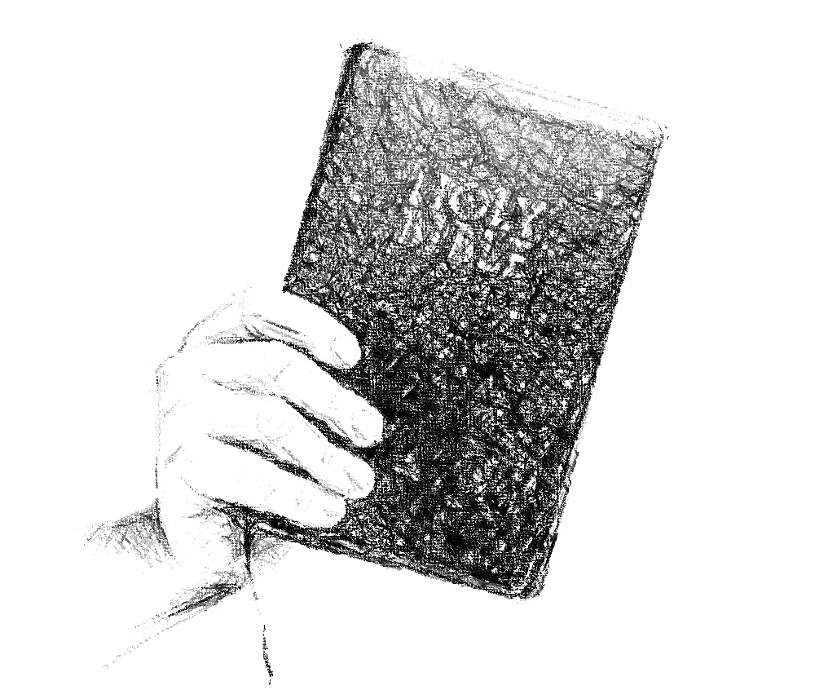

***Exton***

**CHURCH OF CHRIST**

217 North Whitford Road

Exton, PA 19341

**Phone**: 1-610-363- 8042

**Email**: [extonpachurch@gmail.com](mailto:extonpachurch@gmail.com)

**Website**: [www.extonchurch.org](http://www.extonchurch.org)

Like snow in summer or rain in harvest,  
 so honor is not fitting for a fool.

Proverbs 26:1

**Volume 2, Issue 25**

The Kind of Preaching

We Need

People may have various views about preachers and their work, but the Bible plainly states the kind of preaching that is needed in the world today. We need preaching that is:

1.

**Bible-based.** The Lord told Jonah to "preach the preaching I bid thee"(Jonah 3:2). Some preaching is pleasant to hear and it entertains people, but it leaves them sadly uninformed about what God really wants.

2.

**Doctrinal:** Paul urged Timothy to "take heed unto thyself, and unto the doctrine; continue in them: for in doing this thou shalt both save thyself, and them that hear thee" (1 Timothy 4:16). Doctrine is distasteful to some folks, but it is essential to the saving of the soul.

3.

**Direct and Personal:** Preaching that doesn't deal with the real problems and sins of people is of little value. We should not be unkind, but we need to "get to the point." John the Baptist set a wonderful example and lost his head for doing so (Mark 6:18).

4.

**Motivated by Love:** We won't succeed in reaching people if they can't see that we truly care about them. But when we "speak the truth in love"(Ephesians 4:15), we will be able to help people deal with the toughest problems.

5.

**Full of Conviction:** You have to have a deep faith in the message you proclaim. As Paul said, "I believed, and therefore did I speak" (2 Corinthians 4:13).

6.

**Bold:** Some men check to "see which way the wind is blowing" before they speak. Instead of this, we should speak "with all boldness"(Acts 4:29).

7.

**Balanced:** We need both positive and negative instruction. If we omit either one, we will not be effective in this important work. Paul told Timothy to "reprove, rebuke, exhort"(2 Timothy 4:2), and in doing so he emphasized the need for both positive and negative teaching.

By Greg Gwin

Bulletin of the Church of Christ at Birchwood Avenue, In Louisville, KY